BEE KEEPING APPRAISAL MANUAL
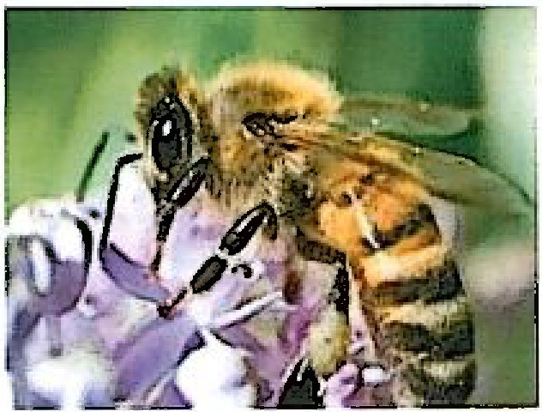
PALO PINTO APPRAISAL DISTRlCT

TABLE OF CONTENTS

Degree of Intensity…………………………………………………….……….3

Productivity for Beekeeping…………………………………………………...4

Filing Deadline………………………………………………………………….4

Late Applications……………………………………………………………….4

Action of Applications………………………………………………………….4

Additional Information………………………………………………………….4

On-Site Inspections…………………………………………………………….4

Denial of Application……………………………………………………………5

Productivity Value for Beekeeping……………………………………………5

Definitions of Common Terms………………………………………………...6

BEE KEEPING
DEGREE OF INTENSITY
Per Texas Tax Code Sec 23.51 (2)...Beekeeping is an agricultural use and shall qualify for agricultural use productivity valuation if used for pollination or for the production of human food other tangible products having a commercial value, provided that the land used is not less than five {5) acres or more than twenty (20} acres.
Acreage Requirement: The State of Texas has set a minimum of 5 acres and a maximum of 20 acres to qualify beekeeping as an agricultural use.
The degree of intensity standard for Palo Pinto County is set at a minimum of six (6} colonies and five (5} acres. The minimum degree of intensity was established using Section 131.001 Texas Agriculture Code's definition of an apiary, which is a place where six {6) or more colonies of bees or nuclei of bees are kept. A colony is the hive and its equipment and appurtenances including bees, combs, honey, pollen and brood.
For each additional 2.5 acres one (1} additional hive is required. If additional acreage is less than 2.5 acres, no additional hive is required. For example, if a property owner has 14.6 acres of land used for beekeeping nine (9) hives would be needed to qualify.

First 5 acres 6 hives

Additional 7.5 acres 3 hives Remaining 2.1acres 0 hives Total Hives Required 9 hives

When property owner initially qualifies for agricultural appraisal, they must show proof of history for agricultural use/ beekeeping for any of the five (5) preceding seven (7) years. One way to do this is to ask for export, import or intra-state permits, which are required by the Texas Apiary Inspection Service to transport hives.

Productivity for Beekeeping
Bees may qualify on tract of land from 5 to 20 acres. Bees can be used to establish history with supporting documentation. Hives must be maintained and kept alive. Twelve (12) hives would be required on 20 acres. Flowering plants must be planted to support hives if the hives are in areas where there is limited vegetation that requires pollination. Appraisal district will grant agricultural use on the total acreage, not use on the area where the hives sit.
FILING DEADLINE
The deadline for applications is ''before May 15\" meaning the application form must be postmarked or filed no later than midnight April 30th.

LATE APPLICATIONS
The property owner may file a late application up until the appraisal review board approves the appraisal records for that year. This usually occurs around the middle of July. However, there is a penalty for late application. An application filed after April 30th is subject to a penalty equal to 10% of the difference between the tax if imposed at market value and the tax imposed at the agricultural productivity value. The chief appraiser must note the penalty in the appraisal records and send the property owner written notice explaining the reasons for the penalty.

ACTION ON APPLICATIONS
The chief appraiser or her designee must review each application and decide to approve it and grant agricultural appraisal, disapprove it and ask for more information, or deny the application. The chief appraiser must determine the validity of all timely filed applications before she turns the appraisal records over to the appraisal review board. The chief appraiser usually gives the appraisal records to the appraisal review board by May15th. The chief appraiser must also review all late applications before the appraisal review board approves the appraisal records. If she denies an application, she must notify the applicant in writing within five days. The applicant then has 30 days to file a protest with the ARB. All properties that have been approved for Bee Keeping will be asked to reapply every three (3) years.

ADDITIONAL INFORMATION
If the initial application does not contain all the information needed to determine whether or not a property qualifies, the chief appraiser may request additional information. The applicant must provide additional information within 30 days after the date of the request or his application will be denied.

ON SITE INSPECTION
All tracts of land associated with an application are inspected via a field visit to the property to determine if the information provided on the application is accurate. Upon inspection of the property, the appraiser will look for signs of Bee Keeping use and make notes of what is seen or not seen. Pictures of the property and evidence of Bee Keeping equipment, active hive boxes, safety equipment, receipts, logs of honey production, plantings that contribute to the bee's foraging may also be taken at this time. A determination is then made either to grant or deny the Bee Keeping valuation and the application. If the application is denied, the applicant is notified by certified mail with a reason for the denial. If the application is approved, it will be dated and initialed by the appraiser. After the agricultural use is entered into the property, the agricultural use application is scanned in to the account.

DENIAL OF APPLICATION
If the application is denied, the chief appraiser shall deliver written notice to the applicant within 5 days after the date he makes the determination. The notice shall include a brief explanation of the procedures for protesting his action and a full explanation of the reasons for denial of the application. All denials are mailed out by certified mail within 5 days of determination of denial.

ROLLBACK TAX
If/when your land receives agricultural valuation for bees or any other ag qualifier and you later have a change in use of that property and fail to notify the chief appraiser of that change in use, you may be required to pay a penalty. You may be required to pay a substantial additional tax (the difference between full ad valorem tax and what you were currently paying for your agricultural valuation) if you stop using all or part of the property for agriculture. Taxes recaptured for the five years preceding the year of change of use.

HOMESTEAD RULES
Typically, 1 acre is held out for homesteaded properties. This reduces the available acres for agricultural valuation. If you own 5 acres and have a homestead on the property you will need 1 additional acre for a total of 6 acres to qualify for the lower end of the 5 acres needed for Bee Keeping. PPAD does not currently allow multiple owners to join together to meet the 5 acre minimum. Each owner must meet the 5 acres minimum on their own.

Productivity Value for Beekeeping
Bees may qualify on tract of land from 5 to 20 acres. Bees can be used to establish history with supporting documentation. Hives must be maintained and kept alive. Twelve (12) hives would be required on 20 acres. Flowering plants must be planted to support hives if the hives are in areas where there is limited vegetation that requires pollination. Appraisal district will grant agricultural use on the total acreage, not use on the area where the hives sit.
Under Open-Space Productivity Valuation, values are calculated using a modified income approach to determine the per acre value. This is done using cash lease rates. The challenge with determining a productivity value for beekeeping using the cash lease method is that usually beekeepers do not lease the land on which the hives are located. In most instances, a property owner who has hives located on his land has an open-space valuation on their property.
Using the basic income/rate/value (IRV) formula for developing an income approach to value, we developed a productivity value for beekeeping.
In Texas it is estimated that an established hive will produce an average of 60 pounds of honey per year. PPAD estimates an average of $60.00 per hive per year for expenses. The average wholesale price for honey is $2.10 per pound. The following is Palo Pinto Appraisal District's calculation.

Total Income per Hive

Total Expenses per Hive per year 'Net Operating Income (NOI) Productivity per hive
60.00 lbs x $2.10 = $126.

$60.00

$126. - $60.00 = $66.00
$66. I .10 cat rate= $660.

PPAD's degree of intensity is 6 hives on the first 5 acres with 1 hive for every additional 2.5 acres up to 20 acres. This would give you a range of 6-12 hives as minimum requirement.
The productivity value is applied on a per-acre basis. Therefore, the following formula is used:

PPAD's minimum requirement on 20 acres is 12 hives. Therefore, the average hives per acres is 12/20= .60 hives.
$660.00. x .60 = $396. or $390.00 per acre.

Beekeeping or Apiary - Max of20 Acres | 5 Acres | 5-12 Acres min of 6 Hives 13-20 Acres min of½ Hive per Acre

Definitions of Common Terms Used in Agricultural Land Appraisal

Qualified Open-Space Land - Land that is currently devoted principally to agricultural use to the degree of intensity generally accepted in the area and that has been devoted principally to agricultural use or to production of timber or forest products for five of the preceding seven years or land that is used principally as an ecological laboratory by a public or private college or university. Qualified open-space land includes all appurtenances to the land. For the purposes
of this subdivision, appurtenances to the land means private roads, dams, reservoirs, water wells, canals, ditches, terraces, and other reshaping of the soil, fences, and riparian water rights.

Agricultural Use - includes but is not limited to the following activities: cultivating the soil, producing crops for human food, animal feed, or planting seed or for the production of fibers; floriculture, viticulture, and horticulture; raising or keeping livestock; raising or keeping exotic animals for the production of human food or of fiber, leather, pelts, or other tangible products having a commercial value; and planting cover crops or leaving land idle for the purpose of participation in a governmental program or normal crop or livestock rotation procedure. The term also includes the use of land for wildlife management.

Change of Use - a physical change, the owner must have stopped using the land for agriculture.

Apiary or Beekeeping- This operation involves the placing of hives in order for the honeybee to produce honeycomb. This honeycomb is processed into pure honey food product for human consumption. The hives are placed in groups in an open pasture.

